Asia-China-Coin-Multiple order-inexpensive

Order details Printer friendly page

Sold by

[linzhoulin](http://myworld.ebay.com/linzhoulin) ( [3120](http://feedback.ebay.com/ws/eBayISAPI.dll?ViewFeedback&userid=linzhoulin)  )

+ Show additional actions

Delivery package 1 of 1

Estimated delivery Monday, Jan 27, 2014 - Wednesday, Feb 12, 2014

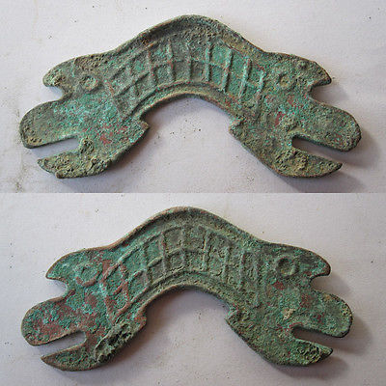

Not in Coole 1976(5)

[Warring States period Tiger head bridge coins 041824](http://www.ebay.com/itm/161185086411)

Item price

$19.88

Quantity

1

Item number

161185086411

Shipping service

Economy Shipping from outside US

[Leave feedback](http://feedback.ebay.com/ws/eBayISAPI.dll?LeaveFeedbackShow&useridfrom=802-867&useridto=linzhoulin&item=161185086411&transactid=0) [Contact seller](http://contact.ebay.com/ws/eBayISAPI.dll?FindAnswers&frm=3998&iid=161185086411&redirect=0&requested=linzhoulin) [Return item](http://return.ebay.com/ws/eBayISAPI.dll?ResolveReturn&eventName=viewSelectedItem&TransactionId=0&ItemId=161185086411)

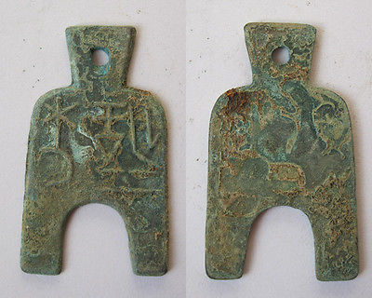

[Warring States spade the original coin 041822](http://www.ebay.com/itm/161187154932)

Item price

$19.88

Quantity

1

Item number

161187154932

Shipping service

Economy Shipping from outside US

[Leave feedback](http://feedback.ebay.com/ws/eBayISAPI.dll?LeaveFeedbackShow&useridfrom=802-867&useridto=linzhoulin&item=161187154932&transactid=0) [Contact seller](http://contact.ebay.com/ws/eBayISAPI.dll?FindAnswers&frm=3998&iid=161187154932&redirect=0&requested=linzhoulin) [Return item](http://return.ebay.com/ws/eBayISAPI.dll?ResolveReturn&eventName=viewSelectedItem&TransactionId=0&ItemId=161187154932)

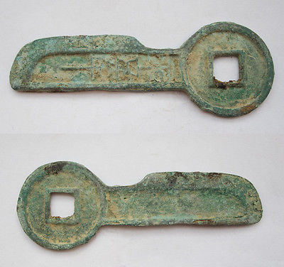

[China Han Dynasty Key original coin 090240](http://www.ebay.com/itm/380806002378)

Item price

$19.88

Quantity

1

Item number

380806002378

Shipping service

Economy Shipping from outside US

[Leave feedback](http://feedback.ebay.com/ws/eBayISAPI.dll?LeaveFeedbackShow&useridfrom=802-867&useridto=linzhoulin&item=380806002378&transactid=0) [Contact seller](http://contact.ebay.com/ws/eBayISAPI.dll?FindAnswers&frm=3998&iid=380806002378&redirect=0&requested=linzhoulin) [Return item](http://return.ebay.com/ws/eBayISAPI.dll?ResolveReturn&eventName=viewSelectedItem&TransactionId=0&ItemId=380806002378)

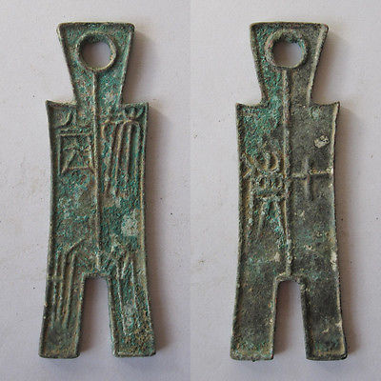

[Warring States spade the original coin 041825](http://www.ebay.com/itm/380806007436)

Item price

$19.88

Quantity

1

Item number

380806007436

Shipping service

Economy Shipping from outside US

[Leave feedback](http://feedback.ebay.com/ws/eBayISAPI.dll?LeaveFeedbackShow&useridfrom=802-867&useridto=linzhoulin&item=380806007436&transactid=0) [Contact seller](http://contact.ebay.com/ws/eBayISAPI.dll?FindAnswers&frm=3998&iid=380806007436&redirect=0&requested=linzhoulin) [Return item](http://return.ebay.com/ws/eBayISAPI.dll?ResolveReturn&eventName=viewSelectedItem&TransactionId=0&ItemId=380806007436)

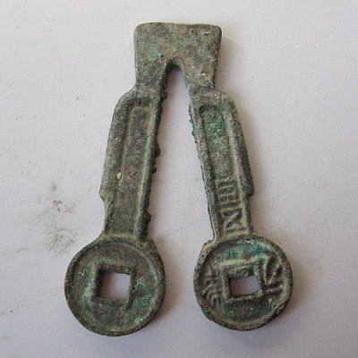

[Warring States spade the original coin 041823](http://www.ebay.com/itm/380806595186)

Item price

$19.88

Quantity

1

Item number

380806595186

Shipping service

Economy Shipping from outside US

[Leave feedback](http://feedback.ebay.com/ws/eBayISAPI.dll?LeaveFeedbackShow&useridfrom=802-867&useridto=linzhoulin&item=380806595186&transactid=0) [Contact seller](http://contact.ebay.com/ws/eBayISAPI.dll?FindAnswers&frm=3998&iid=380806595186&redirect=0&requested=linzhoulin) [Return item](http://return.ebay.com/ws/eBayISAPI.dll?ResolveReturn&eventName=viewSelectedItem&TransactionId=0&ItemId=380806595186)

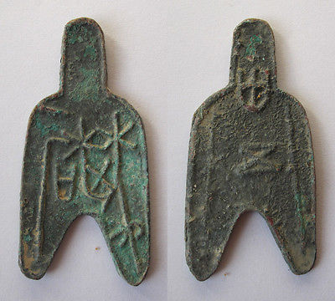

[Warring States spade the original coin 041820](http://www.ebay.com/itm/380807243194)

Item price

$19.88

Quantity

1

Item number

380807243194

Shipping service

Economy Shipping from outside US

[Leave feedback](http://feedback.ebay.com/ws/eBayISAPI.dll?LeaveFeedbackShow&useridfrom=802-867&useridto=linzhoulin&item=380807243194&transactid=0) [Contact seller](http://contact.ebay.com/ws/eBayISAPI.dll?FindAnswers&frm=3998&iid=380807243194&redirect=0&requested=linzhoulin) [Return item](http://return.ebay.com/ws/eBayISAPI.dll?ResolveReturn&eventName=viewSelectedItem&TransactionId=0&ItemId=380807243194)

### Shipping address

Ralph J Coffman Jr  
149 Atlantic Ave   
Swampscott MA 01907-2427  
United States

Phone number  
781 584 7091

### Order total

Subtotal $119.28

Shipping Free

#### Total

## $119.28

[View PayPal transaction](http://payments.ebay.com/ws1/eBayISAPI.dll?IntermediateResolutionInfo&itemid=0&transId=0&pn=UnifiedCheckoutSummaryRedirect2PP&qs=itemid%3D0%26transId%3D0%26buyerorseller%3D0%26)

### Order information

Order placed on  
Monday, Jan 6, 2014

Having a problem with this purchase?  
[Resolve problem](http://res.ebay.com/ws/eBayISAPI.dll?ResolutionCenter)

Payment method   
PayPal

Payment date  
Monday, Jan 6, 2014

|  |
| --- |
|  |
| [Ad Feedback](javascript:void(0);)|[AdChoice **- opens in a new window or tab**](javascript:void(0);) |